**ICT Plan**

Organisation ABC

**Introduction**

This information and communication technology (or ICT) plan is an example which can be used by organisations reviewing their ICT environment and developing their own ICT improvement plan. The information contained in this document is not specific to any one organisation and has been developed as a sample of a typical small-medium sized community organisation.

If you have an example that you think is worth sharing and could benefit other organisations, please let us know – [improveit@infoxchange.net.au](mailto:improveit@infoxchange.net.au)

**Table of Contents**

1. Executive Summary 3

2. How technology supports Organisation ABC 4

3. Assessment of current ICT environment 4

4. ICT Improvement Initiatives 6

4.1 Improvement Initiative – Safeguard Productivity 6

4.2 Improvement Initiative – Enhance IT support 6

4.3 Improvement Initiative – Strengthen ICT capability of the board 6

4.4 Improvement Initiative – Stakeholder Management 7

Appendix A – Current ICT environment 8

Appendix B - Staff survey results 10

# Executive summary

Organisation ABC has built a basic, usable ICT environment within tight budgetary constraints, despite having limited in-house ICT skill. But rapid recent growth of the organisation and an expectation of continued growth mean Organisation ABC needs to reconsider its ICT environment. To realise potential efficiencies from scale and operate effectively as a single organisation, Organisation ABC will need to change both systems and processes and have a plan for change management and training to help staff adapt.

Replacing existing siloed, manual and ad-hoc systems – which most staff find difficult to use – will reduce the time staff have to spend on administrative tasks, letting them concentrate on valuable client-focused activities. By spreading automation, skills and ownership of IT to more staff, management and board members, Organisation ABC can empower its employees to use technology effectively and make the most of technological innovation.

Organisation ABC’s use of ICT was assessed against a best practice framework for non-profit organisations to help identify potential areas for improvement. These are summarised below:



The benefits that will flow through to Organisation ABC and their clients and community from implementing the recommendations include:

* reliably and sustainably providing services without significant risk from technology issues or loss of data
* ensuring that client information is accurate and accessible in a timely manager by all appropriate stakeholders including staff, management and families
* creating efficiencies in processes to reduce staff time spent performing manual administrative processes
* increasing communication, collaboration and transparency across the organisation allowing a more coordinated approach to service delivery
* giving staff and management the skills, support and knowledge that they need to use technology effectively.

Organisation ABC’s use of ICT, the recommended actions, and the benefits are described in more detail in the subsequent sections of this plan.

# How technology supports Organisation ABC

Organisation ABC operates from 4 sites and has approximately 40 staff; over half are casual. The annual turnover is $1.3 million and this is expected to double over the next three years with most of the growth coming through an increase in funding for family support services. Key goals for the organisation over the next couple of years are to:

* Improve service consistency and process maturity so that services can be expanded (doubled) while ensuring service consistency
* Reduce administration effort and increase client-facing activities
* Enable collaboration, information sharing and work independent of location as we expand into new sites and locations

While some things work well from an ICT perspective, there are also a range of issues and new opportunities, outlined below.

|  |  |  |
| --- | --- | --- |
| **ICT that works well** | **ICT issues** | **New ICT opportunities** |
| * Low cost * Email and file server provides but functional environment in the main office * Staff are familiar with current systems and processes | * Inconsistent processes across sites * Lack of staff skills and knowledge in ICT to utilise existing systems * Multiple sources of information (and Excel spreadsheets) for data * Lack of access to all systems remotely * Inconsistency of software versions on each PC * Minimal investment in ICT | * Interacting more proficiently with clients * Automating processes * Moving to cloud based solutions to be accessed from anywhere * Consolidating databases and applications to minimise duplication. |

|  |  |
| --- | --- |
| **Organisation ABC ICT Environment details** | |
| **Number of PCs** | Approximately 40 |
| **Number of servers** | 2 (at head office)  3 (one at each regional office) |
| **Infrastructure support** | Office administration manager (level 1 support)  Friend (volunteer ad-hoc level 2 and server support) |
| **Number of sites supported** | 4 Sites |
| **Number of staff** | Full time: 22  Part time & casual: 32 |
| **PC hardware** | Typically Dell. Desktops and laptops |
| **PC operating systems** | Various including Windows XP and Windows 7 |
| **PC software** | Various version of Microsoft Office including 2007 and 2010 |
| **Anti virus** | Sophos - approximately 20 PCs (remainder of PCs unknown) |

Refer to Appendix A for further details of the current ICT environment.

# Assessment of current ICT environment

Organisation ABC’s current ICT environment was assessed using the Digital Proficiency framework. The framework (shown below) has six areas of ICT proficiency, each of which is rated at one of four levels – basic through to transformational. The organisation’s ICT proficiency is shown below.

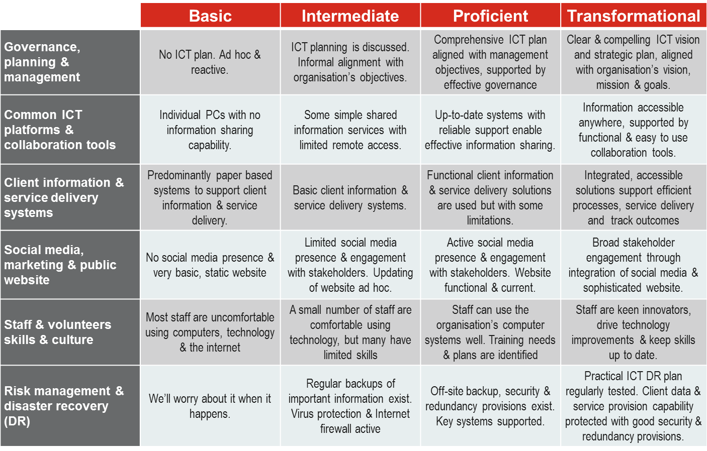

Key factors underpinning the organisations’ proficiency rating above are summarised below.

* **Governance:** There is currently no formal ICT plan, however since a major issue with the server last year there has been a concerted effort at a management and board level to address ICT risk issues. The CEO has led a process to improve the infrastructure, hardware, software versions and potential risk management issues such as backups and licensing.
* **Common IT platforms**: There has been a recent focus on auditing and upgrading all PCs to Windows 7 and gradually replacing the hardware to a standard model. While the new policy is to refresh PCs after 3 years, there are still several PCs out of warranty and over six years old. Connectivity is currently an issue at several sites and staff regularly have trouble accessing their finance system or documents on the central server through Terminal Services. While there is a central email Exchange, only 30 staff have emails and they are currently set up as POP which stores emails on each local PC and doesn’t allow for effective sharing of calendars and contacts.
* **Client information management and service delivery**: All of the client information is currently stored as documents on the central server and accessed through Terminal Services. While this information seems to be maintained in a structured format, the functionality and accessibility is limited and without permissions, version control, high level security and online backups, there are risks associated with this method of document storage.
* **Public presence**: Organisation ABC’s public presence through the website is basic but functional and use of social media is limited. If Organisation ABC wants to expand into more fee-for-service enterprises and use the website as a key marketing tool it will require redevelopment, including functionality for online payments, program registration and service requests. The website should also integrate social media content, particularly as this may be a key platform to increase Organisation ABC’s public presence.
* **Staff and volunteer skills and culture:** The majority of the workforce at Organisation ABC have limited ICT knowledge, skills or interest. The staff survey found that only 30% of staff were satisfied or highly satisfied with their ICT knowledge and yet 70% reported that they use ICT often in their role. Refer to Appendix B for the full results of the staff survey.
* **Risk management and disaster recovery:** Since a major issue with the server occurred in 2013, there have been significant improvements in ICT risk management and disaster recovery practices and IT is a key component of the organisation’s risk management plan. There are now documented backup and restore procedures for all servers and site PCs as well as registers for software and hardware. There have also been upgrades to servers, PCs and software to prevent issues.

Further details about Organisation ABC’s existing ICT environment can be found in Appendix A.

# ICT improvement initiatives

Based on the findings of the assessment, staff survey and the status of the current ICT environment, four key improvement initiatives have been identified to improve the value of ICT.

## Improvement initiative – safeguard productivity

To safeguard the productivity of Organisation ABC’s staff we recommend that you:

* implement a password policy with relatively complex passwords that are regularly changed
* identify which information is really critical and must be kept safe, and ensure it is being regularly backed up and stored off-site
* purchase antivirus through ConnectingUp[1] when the existing licenses are due for renewal (and start using ConnectingUp for all possible software purchases)
* review/refresh your policies to ensure they clearly articulate staff ICT obligations – e.g. password protection, storing documents in the right area and backing them up
* develop processes to ensure you keep all this information up to date
* develop formal support arrangements, including confidentiality provisions, with your ICT support organisations.

**Indicative cost and effort:**

Password policy: < 1 day

Ensure all critical information is being backed up: < 1 day

Symantec’s anti virus products start at $5 per PC per annum from ConnectingUp plus less than 1 hour per PC to install & configure

**Benefits:**

High risk reduction - these improvements will ensure that Organisation ABC is unlikely to suffer from lost productivity or data as a result of equipment/building failure, virus or theft/loss.

## Improvement initiative – enhance IT support

While the current administration staff member has reasonable ICT skills, and Organisation ABC also uses a volunteer to assist with ICT work, we expect that additional more technical, professional support will be required from time-to-time. Finding someone who can provide this extra assistance will ensure you have reliable support for more complex queries, and professional assistance if you have major problems.

Once you select a provider, ask them to review/refine your backup processes (e.g. automate the backup process further and review or write processes to test a restore every 3 - 6 months to confirm your backups work well.)

**Indicative cost & effort**: 1 day effort plus perhaps $400 for your IT provider to review existing backup processes.

**Benefit**: Medium (risk reduction) – to ensure that Organisation ABC has high quality, local ICT advice available when it is required to minimise potential risk and assist in the case of any significant problem.

## Improvement initiative – strengthen ICT capability of the board

Information and communication technology are important enablers of organisational effectiveness. Given the recent regulatory changes and the growth of the organisation, we recommend that the Board’s ICT capability be strengthened. The Organisation ABC team recognises there is not currently a close and trusted ICT advisor able to provide guidance to the team. We think that your Board should include at least one individual who can provide appropriate ICT guidance and expertise.

A recent survey of 1300 community and non-profit organisations across Australia and New Zealand found that organisations with an IT-skilled director on the Board are much more likely to be satisfied with their ICT capability.  We acknowledge that the pool of potential board members is low in the regional area, but AICD and Leadership Victoria may be able to help match directors with IT skills to the Board.  When bringing in an ICT-skilled director, Organisation ABC would need to consider very carefully the cultural fit into the existing Board constituency.

**Indicative effort/cost**: Low – a few days to find the right person, over a period of months.

**Benefit:** Medium – to ensure that Organisation ABC is well placed to get the most from your technology investment and minimise future issues.

## Improvement initiative – client management

Organisation ABC needs a client management system to support all their services. This will give Organisation ABC a flexible system that would simplify processes, allow the introduction of new service streams, automate many of the reports for funders and cater for electronic case notes if required. The system could also enable remote as well as internal access so that data can be directly entered rather than being hand-written and/or re-keyed between files or systems.

Before selecting any software package, consider and document your requirements for the system, consider more than one option, and weigh both functionality and total lifecycle costs of any system. Unless your requirements are very simple, Infoxchange recommends that you engage professional help to build your requirements and possibly help with system selection.

If possible, we strongly advise Organisation ABC to select a package rather than custom develop a system, and to develop and document your requirements.

**Indicative cost and effort:** 9 months and between $15,000 and $25,000 to acquire plus $10,000 – $15,000 ongoing on the package you select (this cost can be better quantified after the requirements and a short list of systems are identified).

**Benefits**: high productivity & service quality gain. The new system will simplify processes, provide the flexibility to introduce new service streams, automate generation many funder and management reports, and also cater for electronic case notes.

# Appendix A – current ICT environment

The following information about Organisation ABC’s current ICT environment was gathered during the course of developing this IT plan. It is provided below for information, and it underpins the Digital Proficiency Assessment in section 2

There is no **client system or system of shared files**. The records are largely paper based with some case notes in Word. The team leaders collate the statistics required for reporting on their own PCs. Some contracts involve case notes, and being able to measure outcomes is really important.

The **website** is basic and functional and is updated occasionally by a volunteer. **Social media** is not being used yet. Organisation ABC is conscious of the need for regular updates and monitoring if they do set up social media accounts.

**Email** is via individual accounts, using POP to each person’s PC and accessed through Outlook. Email is working satisfactorily, though it is difficult to get new accounts added or removed because only one staff member knows how to manage the email exchange. There is no easy way to share **contacts**.

**MYOB is used for finance and payroll** and is working well. It runs on the finance administrator’s PC.

Without a central server, **backups** are the responsibility of the user of each PC. Backups are done to pen drives, with the finance administrator backing up to a hard drive which she takes home.

There are 20 licences for Sophos **antivirus** and it is set up on all the PCs and is kept up-to-date. The remaining netbooks and latops use the free version of AVG antivirus. When it is due for renewal, Organisation ABC should consider purchasing Symantec antivirus though ConnectingUp as it is an equivalent product at a considerably cheaper price.

There are no formal arrangements for **ICT support**. Organisation ABC has recently started using a local volunteer for support on an ad hoc basis. However, if the organisation does start using more complex ICT, such as a client management system, a more formal arrangement for support may be necessary.

There are **40 PCs, 4 laptops, and 5 netbooks** using a mix of Windows 7 and XP, and Office 2010 and 2007. The oldest PC has Office 2000 and is in the public area. It is provided for clients to get access to the internet. All the PCs audited had up-to-date antivirus and were set to auto update their Windows and Office software. In the past software has been purchased at retail prices.

A new heavy-duty Canon iRC3080i **multi-function printer** has recently been leased. Everyone has access so the individual inkjet printers attached to each PC are being decommissioned as their ink cartridges run out.

There are four new Samsung Galaxy **phones** for the senior staff, just acquired on a two-year contract. There is also an 0800 service number for clients.

The **internet access** is ADSL with WPA2 wireless connectivity throughout the main building. Because the wireless signal to the second building is faint, staff use a laptop with a 4G data pack when working there.

Some of the more recently acquired ICT assets are listed below:





**Previous Years ICT expenses**

|  |  |
| --- | --- |
| **ICT Expenses - last financial year** | **Investment** |
| External infrastructure support (local IT provider) | $5,752 |
| Server hardware & software | $1,789 |
| Personal computers (laptops and desktops) | $3,522 |
| PC software | $336 |
| Application license fees (Client management system) | $2,104 |
| Printing (purchase of several new printers) | $2,467 |
| Email | $2,140 |
| Phones (mobiles and landlines) | $5,576 |
| Internet | $2,404 |
| IT Training | $1,000 |
| **Total (ex GST)** | **$27,090** |

# Appendix B - staff survey results

A survey was sent to all Organisation ABC staff to better understand their views about the organisation’s ICT environment.

**Question 1 - On a scale of 1 (highly dissatisfied) to 7 (highly satisfied), please rate your overall satisfaction with information technology in your organisation? 4.1 out of 7 – Neutral**

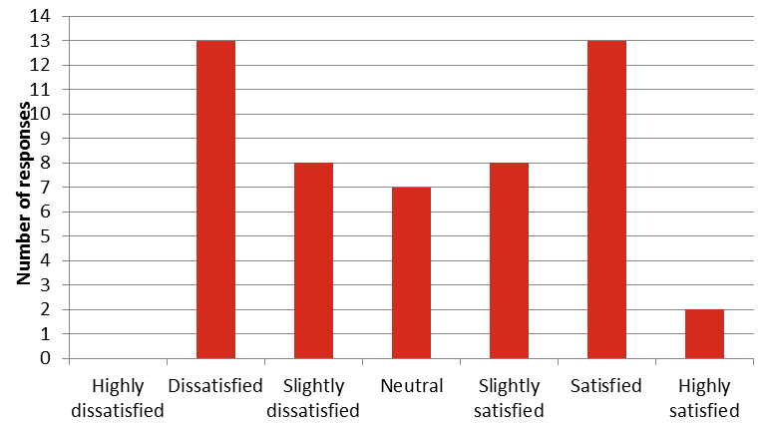

**Question 2 - How often do you need to use a computer at work?** **4.7 out of 5**

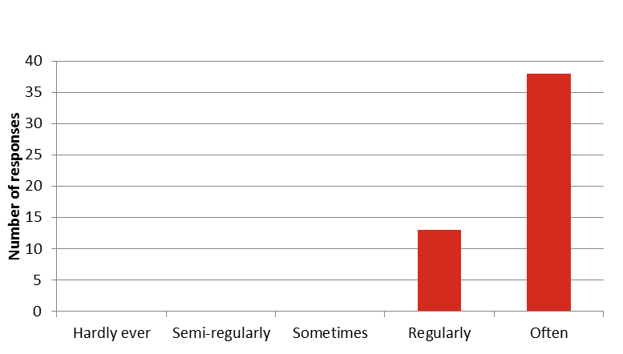

**Question 3 - On a scale of 1 to 7, how satisfied are you with your own skills and ability to get the most out of information technology and perform your role effectively? 5.9 out of 7**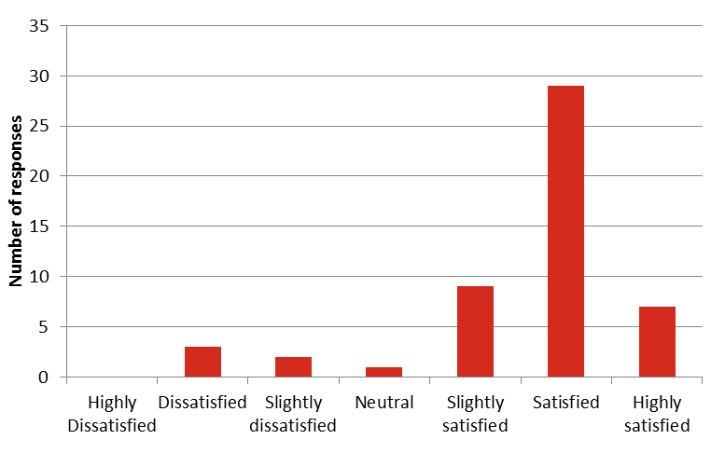

**Question 4 - What two changes to information technology should your organisation consider to help staff work more efficiently and effectively?**

* Greater use of collaboration tools to better share information and connect networks of staff
* access to emails from home to fill the gap on days not worked or important information.
* Setting up process for staff and committee to share whilst maintaining privacy
* Wifi and laptop for staff who work at center and at home.
* Upgrade of all software for all services.
* make intranet more user friendly. I find it hard to find what I want.
* Updated computers,
* Training in updated programs.
* A better way to deal with too many e mails
* iPads or laptop access to all rooms so the staff can program effectively
* Need common operating systems and equipment - we have too much variability across teams
* Getting prompt help when required
* Individual IT support which can be accessed full time and is able to respond quickly to any issues.

1. Also called TechSoup NZ in New Zealand